The 18th British Rowing Tour
Lancaster Canal
1st – 4th September 2011
 | One of the most scenic canals in the country, this gentle waterway offers wonderful views of the Silverdale coast, Forest of Bowland and rolling countryside of Wyre. It was nicknamed ‘the Black and White Canal’ as it originally carried coal from the south and limestone from the north. The Lancaster Canal stretches over 41 miles from Preston to Tewitfield on one level, England’s longest stretch of canal with no locks. | 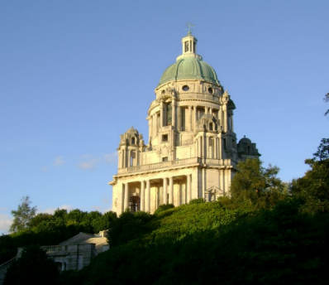  Ashton Memorial, Lancaster
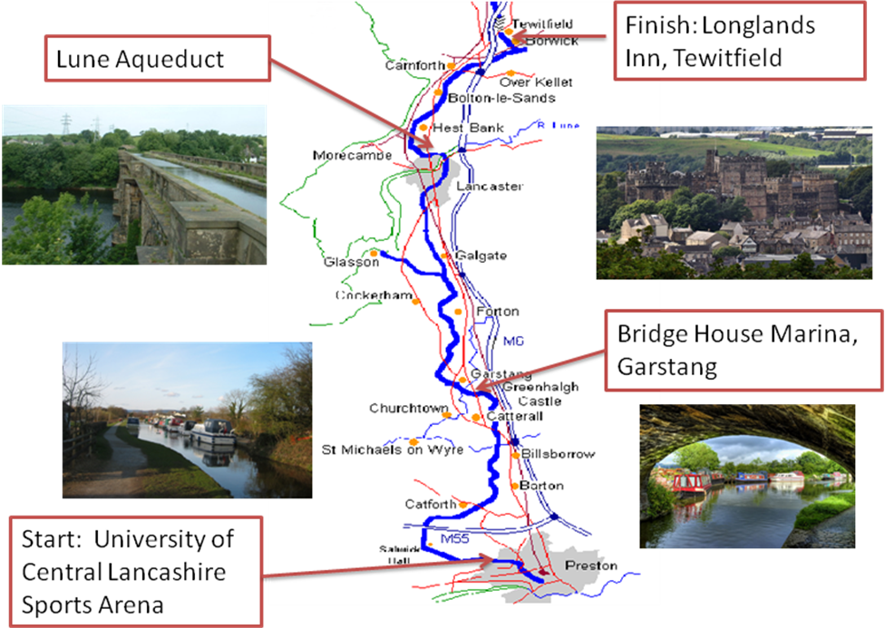

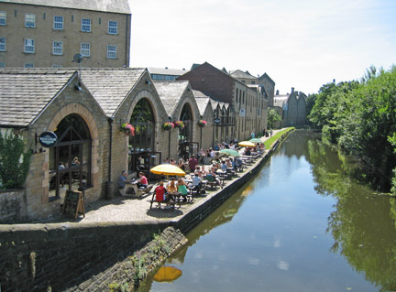  White Cross Public House, Lancaster |  |  | The canal, engineered by Scottish architect John Rennie, has more than 130 bridges and 8 aqueducts, the most impressive being the one over the River Lune, which is 664 feet long and 61 feet high. Construction of the canal started in 1792 and the final section, a 2 ½ mile spur down to the coast at Glasson Docks, was completed in 1826. The Millenium Ribble Link, opened in 2002, now joins the southern end of the Lancaster Canal to the rest of the canal network.
This year’s tour is organised by Weyfarers in assocation with
Lancaster John O’Gaunt Rowing Club

Provisional Programme
Thurday  1st Sept (p.m.) | Boats and trailers to University of Central Lancs Sports Arena, unload and rig  Transfer trailers to Halton Army Training Camp  Check in Lancaster University Conference Centre or Lancaster House Hotel  Informal dinner, Lancaster University
Friday  2nd Sept | Coach from hotel to UCLSA  Row UCLSA to Garstang (22 km)  Picnic lunch en route  Coach to Lancaster / University, visit Maritime Museum  Dinner in Condor Green, on the Glasson Canal Link
Saturday  3rd Sept | Coach to Garstang  Row Garstang to Lancaster (22 km)  Lunch at Craft Centre Tea Room, Galgate  Coach to Lancaster / University, visit Lancaster Castle  Tour dinner Lancaster House Hotel
Sunday  4th Sept | Coach to Lancaster  Drivers transfer trailers to Tewitfield  Row Halton to Tewitfield (16 km)  Lunch at Longlands Inn, Tewitfield  Coach return to Lancaster University if required

Boats
Stable crew boats ONLY, sculling recommended, owing to restricted width of canal. Crews should equip themselves with canoe paddles as some sections (e.g. aqueducts) are too narrow to row.
Seats in coxed quads may be offered for hire to individual participants without their own boat
by clubs with spare capacity.

Further information
John and Caroline Turnbull: Weyfarers@aol.com

Background Note
British Rowing holds a tour every year on a different waterway, to promote recreational rowing as an alternative to racing. Backed by Sport England, BR have recently launched the “Explore Rowing” project, to open up the sport to people of all ages and abilities by helping clubs to buy stable boats and run “Learn to Row” courses. A dedicated website, www.explorerowing.org, contains details of previous tours and general guidance for tour organisers, so that clubs can run tours on their local water and invite others to join in.

