**Head of the Lune 2017**

**Hazards, Safety, Race Routes and Crew* instructions**

*In these instructions “crew” includes single scullers.

The course will be 2500m (approx.) Downstream from above M6 Bridge to the Promenade above Skerton Weir using Halton arch of the Aqueduct and the Halton side of the river. The river will be buoyed and the racing course will be to the right, bowside, starboard side of the buoys.

**TIMETABLE**

* Registration/numbers – from 9.00am
* Coxes/steers/single scullers/coaches **SAFETY** briefing 9.15
* Boating from 9.30amRace start at 10.00am (Division 1) and 11.00am (Division 2)
* Presentation of medals 12.30pm

**SAFETY PLAN**

**Hazards:**

1. Skerton Weir – Keep well away from it and be aware that the current might be pulling your boat towards it. Do not stop in front of the weir. A marshal’s launch will be positioned to warn crews who are too close.
2. Capsize before, during or after the race. Launches will be available to assist, but a crew which capsizes must right their own boat, untangle the oars for towing and begin swimming their boat to the bank.
3. Collision risks:
   1. During overtaking - slower moving crews must move towards the Halton bank and give way to faster crews.
   2. Between a crew racing downstream and a crew proceeding upstream to the start or returning to Halton or Denny Beck landing stages after the race.
   3. In marshalling/starting/finish areas which may be congested.
   4. Two or more crews arriving at the aqueduct at the same time.
4. Observation
   1. Those rowers steering boats must look round frequently.
   2. Marshals will be positioned at the aqueduct on the bank and in a launch above the aqueduct in the middle of the river to direct traffic if necessary.

**Race marshals’ instructions to crews must be obeyed**

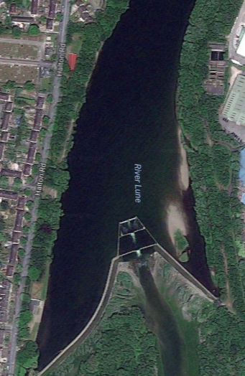

Path of

River current

Racing course

**Skerton Weir**

Buoys

Path of crews moving upstream

**CIRCULATION PATTERN - View of Canal Aqueduct (looking upstream)**

|  |  |  |
| --- | --- | --- |
| **Skerton Side** | Marshal Upstream  Race downstream  **4th**  **3rd**  **2nd**  **1st**  **4th**  **3rd**  **2nd**  **1st** | **Lancaster Side** |

Do not use the partial arch on the Lancaster side. Note the obstruction hazard of jetty piers and part-submerged trees on the Lancaster side below the aqueduct.

Crews may warm up going upstream from Lancaster John O’Gaunt RC boathouse

on the Lancaster (weir) side and return downstream on the racing course unless told not to do so by marshals.

Going upstream to the start, keep away from the weir and inside the buoys on the Lancaster side, away from the path of racing crews.

Crews boating from John O’Gaunt will proceed to the start upstream on Lancaster side using 2nd arch of the Aqueduct.

Crews boating from Halton camp (Lancaster Royal Grammar School) and Denny Beck bridge (Lancaster University) should proceed downstream on Halton side before turning to Lancaster side under direction of Above Aqueduct Marshal (in launch).

**RACE PROCEDURE**

**Preparing to start racing**

1. All crews will marshal in starting order on Lancaster side facing upstream below the M6 bridge. While waiting, keep outer clothes layers on in cold weather.
2. Under direction from Holding Marshal (in launch) they will proceed upstream above the M6.
3. Under direction from Start Marshal (in launch) they will turn and proceed downstream on the Halton side to the Start line.
4. They will be given the order to “Start racing” before reaching the Start line marked by orange buoys

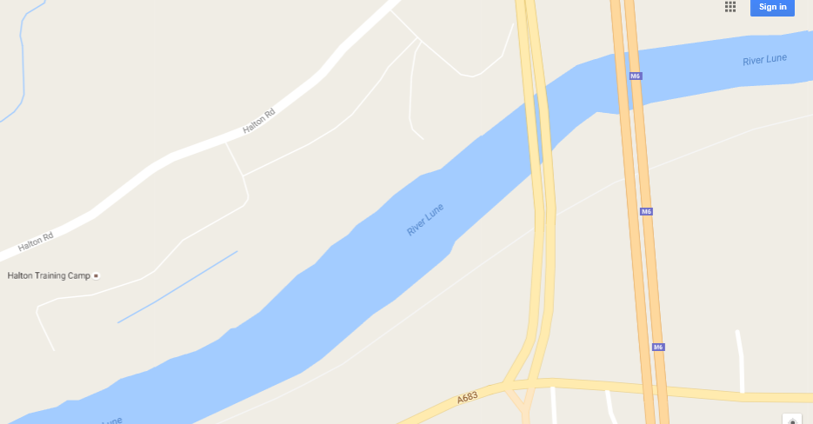

Race course

START

Marshalling area

**During the race**

1. Crews must keep to their own side of the river – downstream on the Halton side.
2. Slower moving crews must give way to faster crews.
3. Use 3rd Aqueduct arch.

4. Avoid collisions if two or more crews arrive at the aqueduct at the same time.

**At the Finish**

1. After passing the finish line marked by large orange buoys, keep moving until told to stop by marshals.
2. Crews returning to Lancaster John O’Gaunt RC boathouse will be instructed to proceed to the landing stages.
3. Crews returning to Lancaster Royal Grammar School BC (Halton Army camp) when told to do so, will turn to proceed upstream on the Lancaster side and turn above the Watch Tower to Halton side to return to the landing stages.
4. Crews returning to Lancaster University (Denny Beck) when told to do so, will turn to proceed upstream on the Lancaster side to return to their landing stages.
5. All crews must get out of their boats and remove them as soon as possible to free landing stages for others.